
SOP Title: | eComm Inbound Delivery Order Creation Process  (eComm to North Dock Transfer)
Document Storage Location: | STACS/Management/SOPs – Logistics and Warehousing | Document #: | SEASOP417v100
SOP Originator: | Viraj Baraskar | Last Edited by: | Avika Raja
Effective Date: | 10/19/2020 | Last Edited Date: | 07/19/2021
Other: | GMP and Synapse accessibility required.

- Purpose
  - To develop a process to create an inbound delivery order from eCommerce (eComm) location to the warehouse (WH) location at the north dock (ND).
- Scope
  - Coppell eComm – Process to occur when an inbound delivery order needs to be created to transfer stock physically as well as systemically out of eComm inventory to the ND inventory.
- Responsibilities
  - The SEA eComm team shall be responsible to create the inbound delivery order in GMP.
  - The 3PL eComm team shall be responsible to transfer the stock physically to the ND location.
  - The 3PL eComm team shall validate the SKUs and perform cycle counts by EOD (end of day).
  - The 3PL ND team shall validate the stock physically and GR it systemically on the same working day.
- Instructions
  - The process begins when a request is made by the Demand Fulfillment (DF) team to transfer a particular quantity of a SKU from the eComm inventory to the WH inventory.
  - The process shall follow the steps to create the inbound delivery as described below:
    - Stock Overview: Confirm that the quantity of the SKU being transferred exists in GMP and 3PL WMS (Synapse).
      - In GMP:
- Log-in to your GMP.
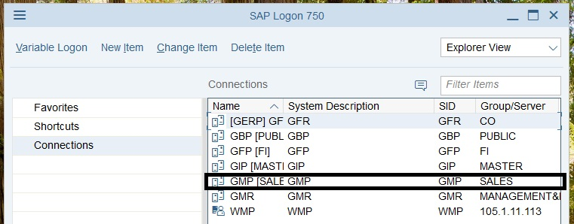

- Use T-code MMBE. Put in the following details:
        - Enter the material
        - Enter the plant – S341
        - Enter the storage location for the inventory,
          - WC1E : eComm Inventory (HHP and ACCY)
          - WC30 : WH Inventory (Good units) (HHP only)
          - WC31 : WH Inventory (Defective units) (HHP and ACCY)
          - WCA1 : WH Inventory (Good units) (ACCY only)
        - Enter the batch – A
  - Click on execute.
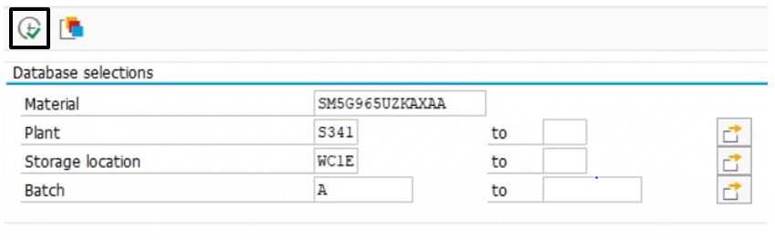
- An inbound delivery can be created against the units under unrestricted seen below:
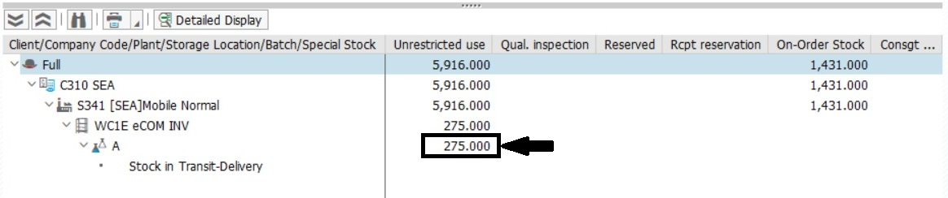
- Scroll to the right to see the blocked units (see 1 below). These units cannot be used to create the delivery. Units seen under Stock in Transit-Delivery (see 2 below) are the orders shipped out and pending delivery to customers.
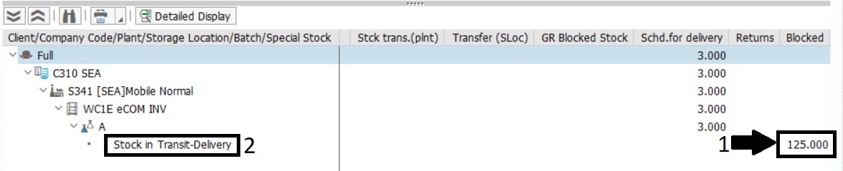
    - In Synapse:
- Log-in to Synapse. Click on Control tower Search Inventory as shown below:
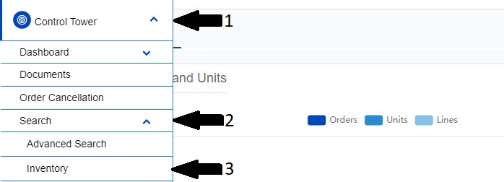
- Enter the SKU and click on search as shown below
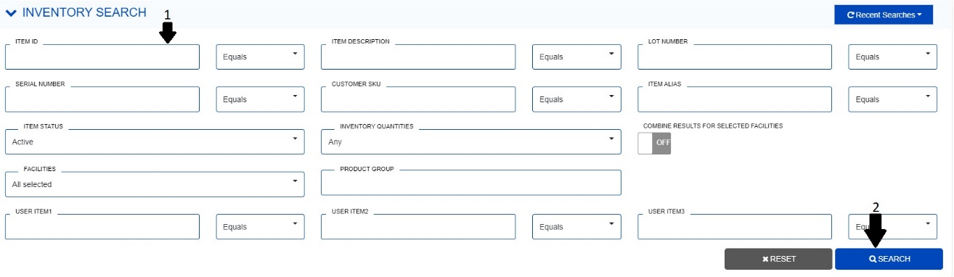
- The inbound delivery can be created against the units in allocable quantity column.
  - The delivery can only be created against the lowest quantity between unrestricted (GMP) and allocable (Synapse).
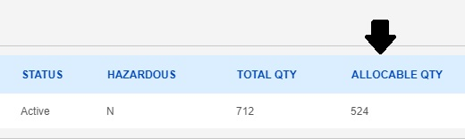
  - Create Purchase Order:
    - Enter T-code ME21N, and enter the following details in the upper part of the window.
      - Select Stock Transport Order.
      - Enter the Supplying Plant – S341
      - Enter the Purchasing Organisation – 3170
      - Enter the Purchasing Group – 3B1
      - Enter the Company Code – C310
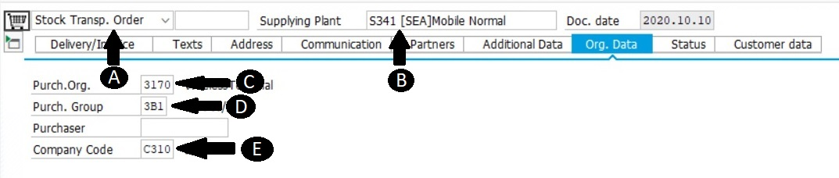
    - In the middle part of the window, enter the following details
      - Enter the material
      - Enter the quantity
      - Enter the plant – S341
      - Enter the delivery location – WC30/WC31/WCA1
      - Scroll to the right
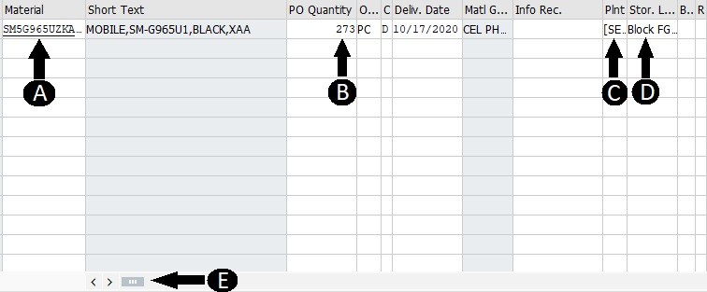
      - As seen below, enter the issuing location – WC1E and hit enter
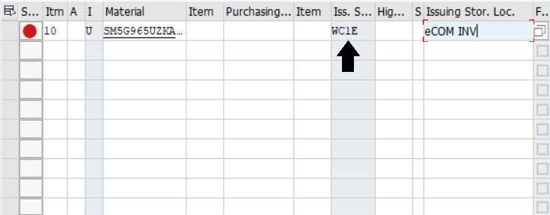
    - In the bottom part of the window, as seen in the two pictures below,
      - Enter the valuation type as “A”
      - Click on Confirmations
      - Select Inbound Delivery and click on save
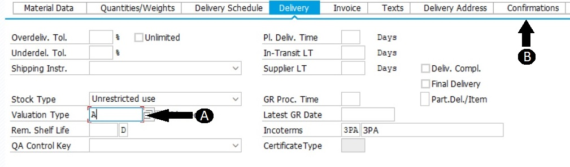
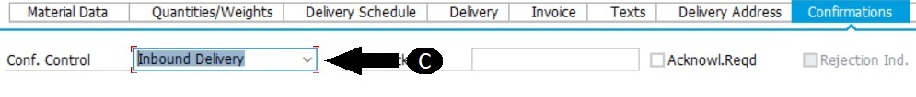
    - Click on the PO number visible on the bottom of the window and copy the PO number.
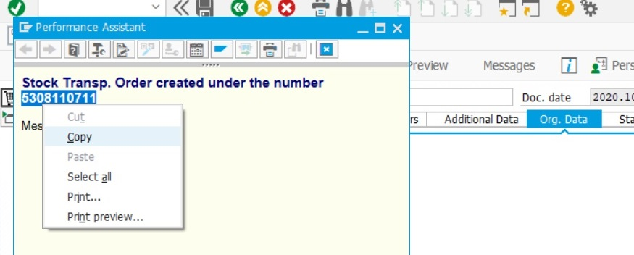
  - Create Stock Transfer Order (STO):
    - Enter T-code VL10B and enter the following details
      - Paste the PO number copied and hit the execute button (F8).
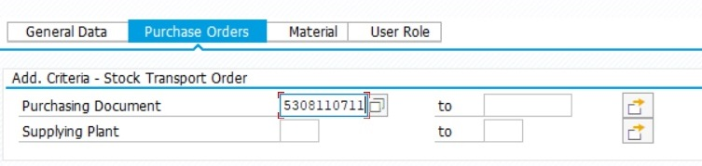
      - The box should be highlighted as seen below.
      - Click on “Background” button.
      - Copy the DO number.
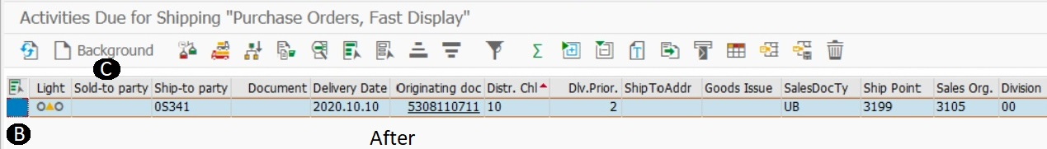
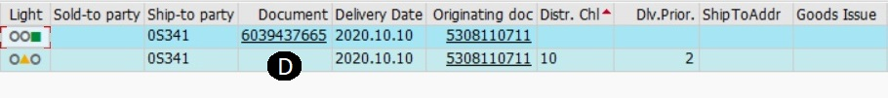
  - Issuing the STO Through 3PL
    - Send an email to 3PL eComm team with the DOs.
    - Once the order is confirmed to have been shipped, go to f. (Creating the Inbound Delivery)
    - If the order did not post correctly in GMP, issue manually.
      - Follow g. (Issuing the STO Manually)
  - Creating the Inbound Delivery:
    - Enter t-code VL31N
    - Paste the PO number if not already pasted and click on enter
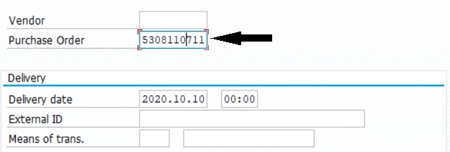
    - Click on save
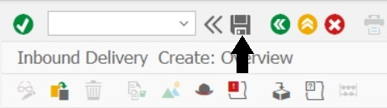
    - Click on the inbound delivery number visible on the bottom
      - Copy the Inbound DO number
    - Share the inbound DO number, quantity and SKU with the North Dock receiving team using the distribution emails:
      - CoppellMGRNorth.cl.us@Geodis.com
      - InboundNorth.cl.us@Geodis.com
  - Troubleshooting/Issuing the STO Manually: For STOs that fail transmission post-GI, follow the procedure below.
    - Enter t-code VL02N and enter the copied DO number (if not already entered).
    - Verify the details for the order and click on Post Goods Issue.
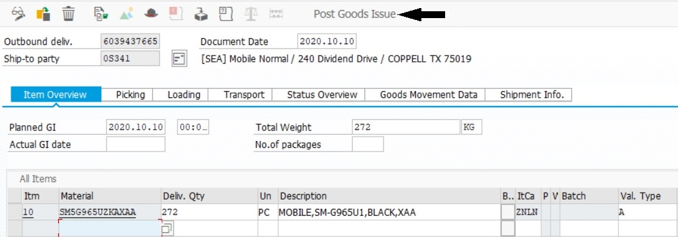
    - Click on document flow
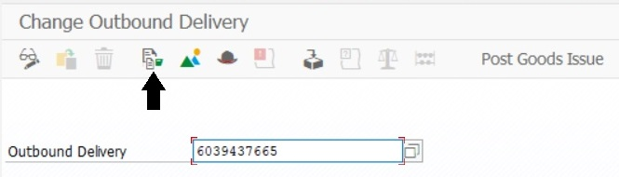
    - Double click on the PO number
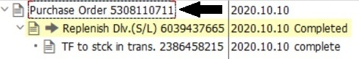
    - Copy the PO number on the bottom part of the screen
